Practical # 02

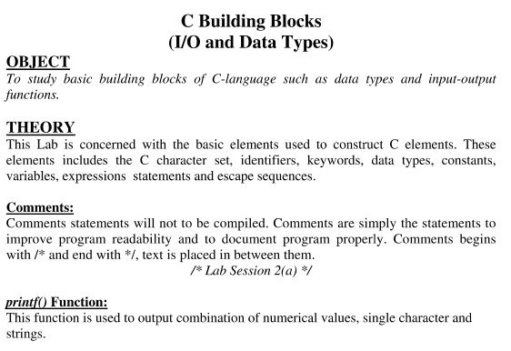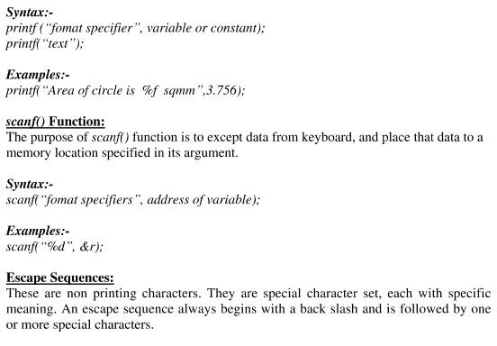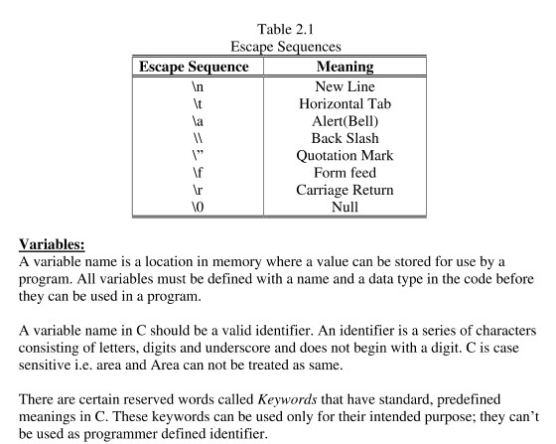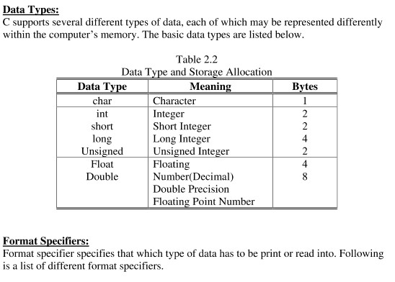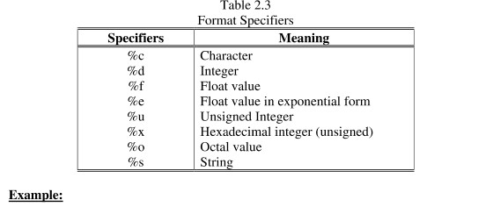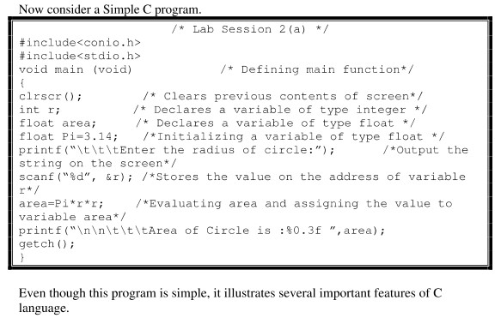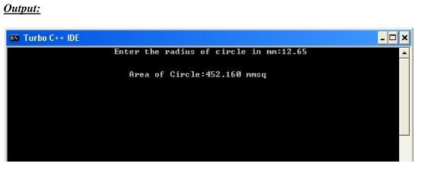

Review Questions/ Exercise:

1. Identify and correct errors in the following statements.
   1. scanf(“d”, value);

- Added % symbol before format specifier (d)

- Added ampersand (&) before variable name (value) to pass address.

* 1. printf(“The answer of %d+%d is”\n,x,y);

__- Added %d format specifier for the answer

- Added x+y to calculate and display the sum

* 1. scanf(“%d%d, &number1,number2);

__- Added space between %d %d format specifiers for two integers

- Added ampersand (&) before each variable name (number1, number2) to pass addresses_______________________________________________________

1. Write a single C statement to accomplish the following tasks.
   1. Prompt the user to enter an integer in the inverted commas.

For example “Enter an integer”

____ printf("Enter an integer: ");

* 1. Read an integer from keyboard and store that value into a variable a. scanf("%d", &a);
  2. Read an integer from keyboard and store that value into variable a & b.

scanf("%d %d", &a, &b);

1. What does these code print?
   1. printf(“\n*\n**\n***\n****\n*****”);

Output:

*

**

***

****

b) printf("This is\base");*

Output:

This is

base

1. printf(“\n\t\t\t1\n\t\t2\n\t3\n4\n\t5\n\t\t6\t\t\t7”);

Output:

1

2

3

4

5

6 7

Name: _____

Roll #: _____

Date: _____

Subject Teacher / LAB Engineer

Remarks: